Report

**Web Site Name:** Roger`s Campground

**Motto:** Enjoy With Roger`s Campground

**Github repo:** https://github.com/iuthub/ip-group-project-g-rou-p

**Team members:**

Bakhbaev Timur u1810177

Maksudov Abdumalik u1810255

Yadgarova Aylisa u1710298

Ismoilova Nargiza u1710302

Durjanova Sevinch u1710305

Brief Information

Our WebSite is created for Roger`s Campground American Campground. Our team member worked in this campsite and its official web site is old version **rogerscampground.com.** We developed it. It includes several activities which is related to Campground.

1. Main Page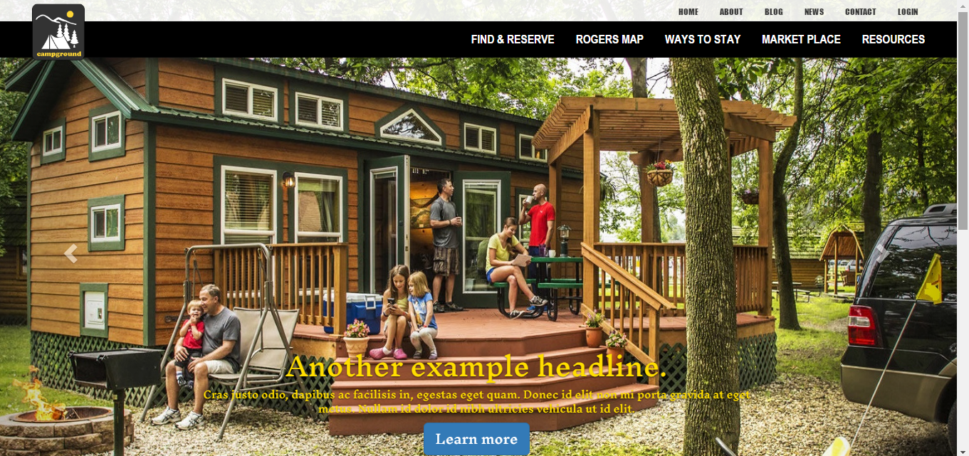

This is our main page which connects all other sub pages. In this page both Admin and Users can log in. In addition new Users can open new account. Below the carousel 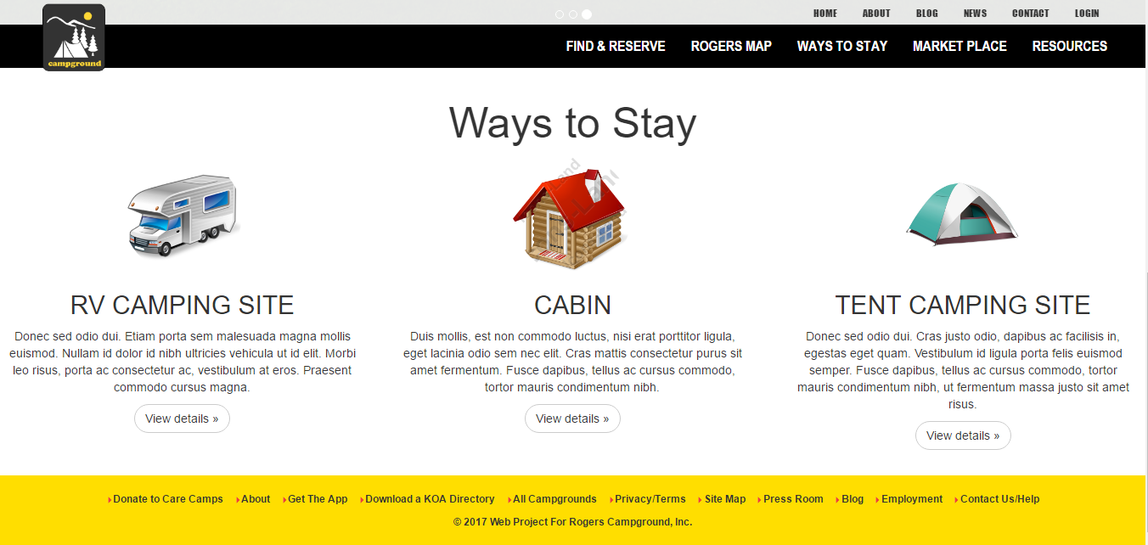

Three types of ways to stay in Campground. Campground offers these ways.

**Admin Username: *Admin***

**Password:  *inha***

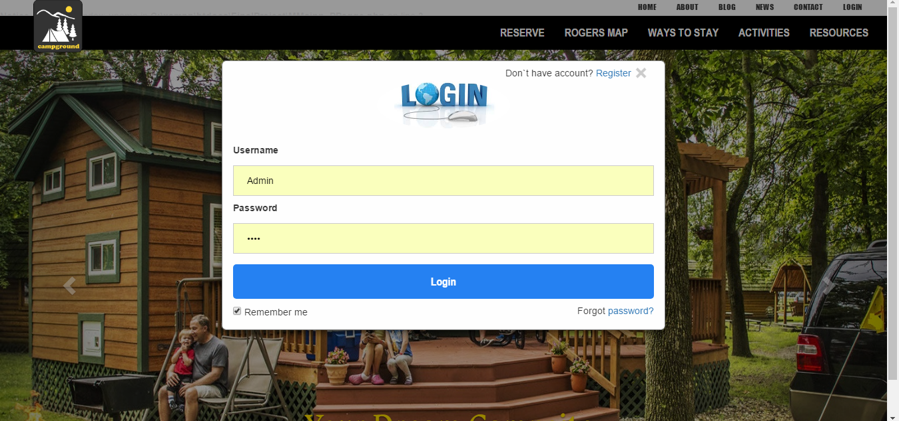

In this part both users and admin can log in. If users haven`t registered yet just press **Register** on top .

Users should fill blanks for registering.

**2)Find and Reserve:** New Guests can reserve a particular type of stay in campground in this page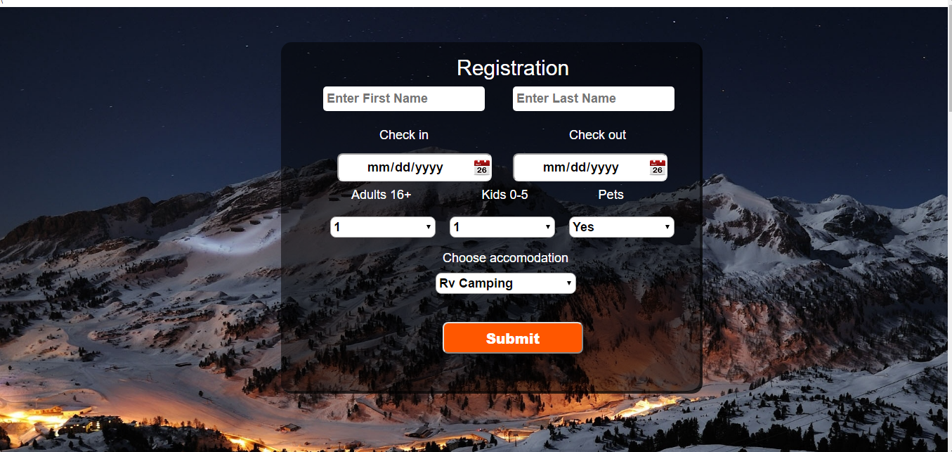

In this part User has to enter all required information to book a place. What is more below user can familiarize himself/herself with brief information about each type of Ways For Example 1)RV Camping, 2) Cabin 3)Tent

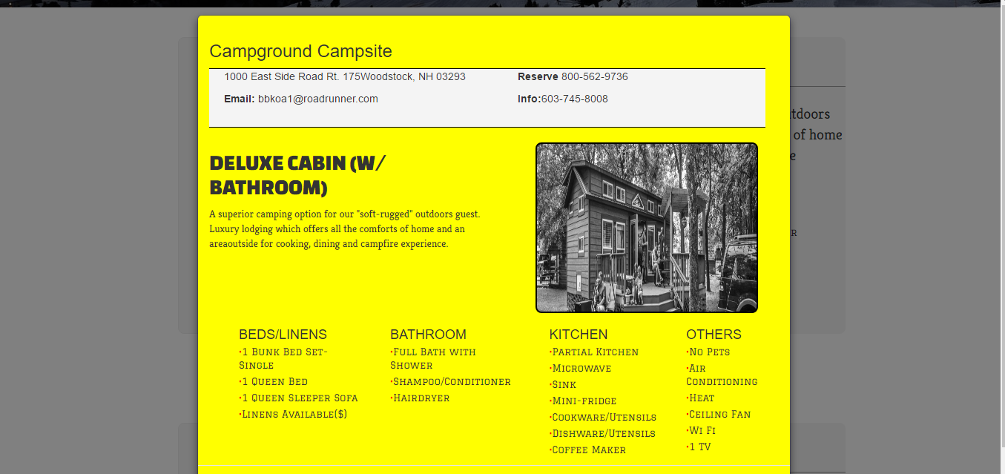

All of the information is saved inside database.

**3)Admin Part:** Admin also can log in from main page. Admin can perform two primary task yet: Manage All users and Control News in News Part.

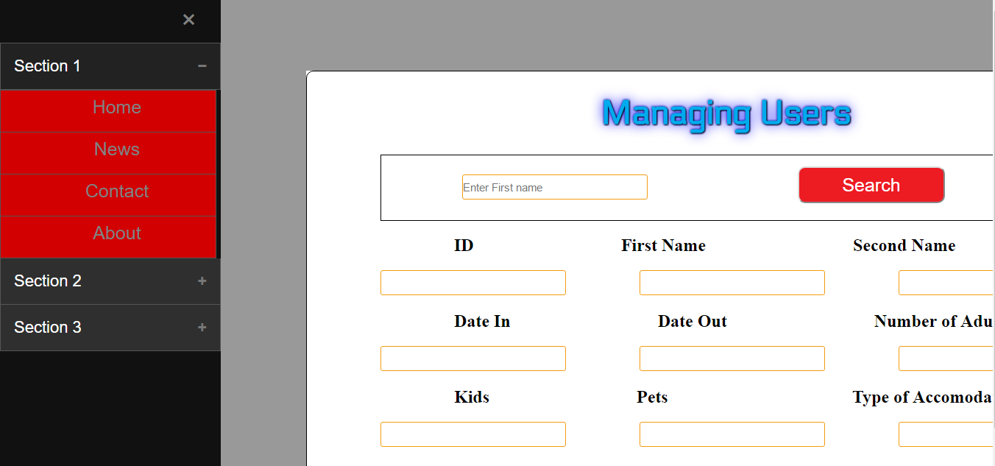

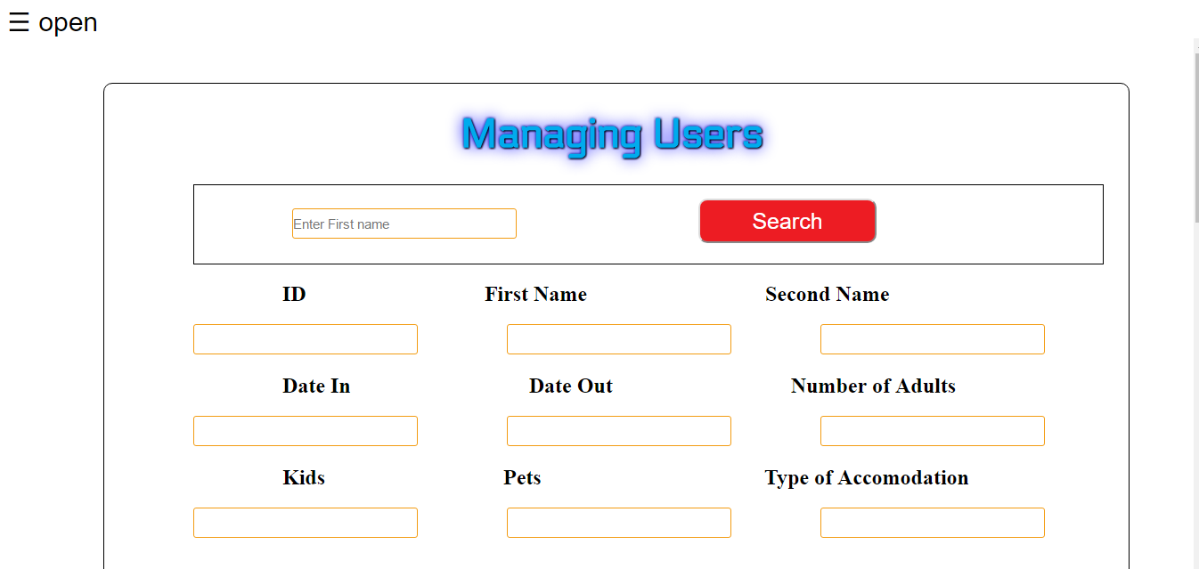

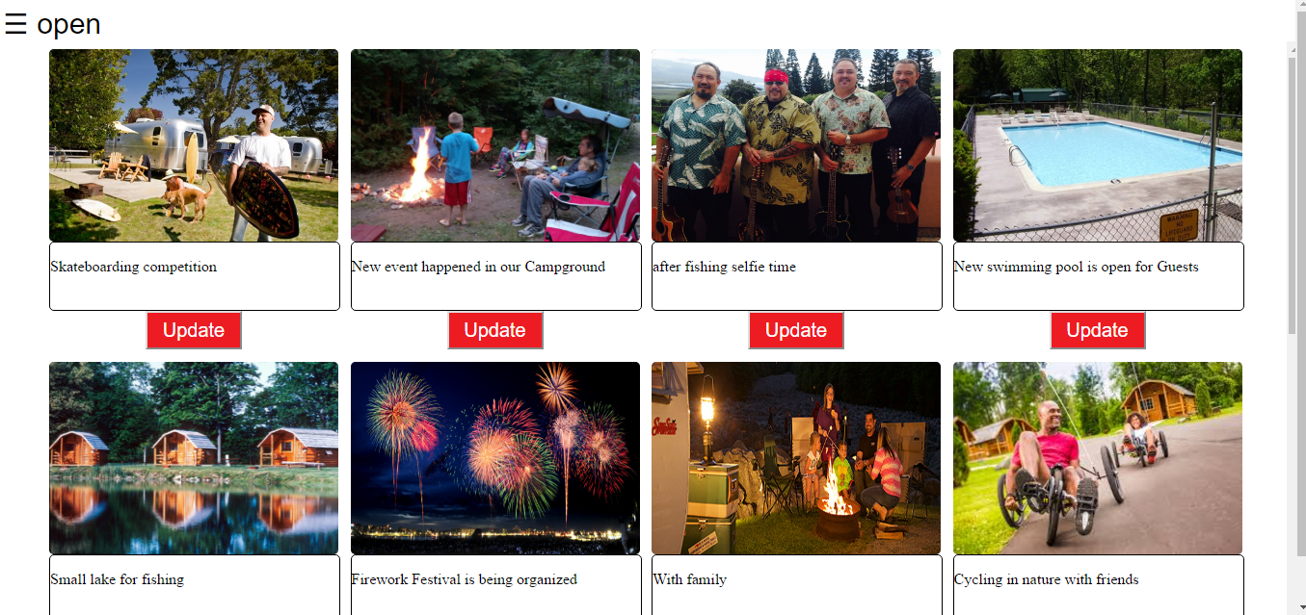

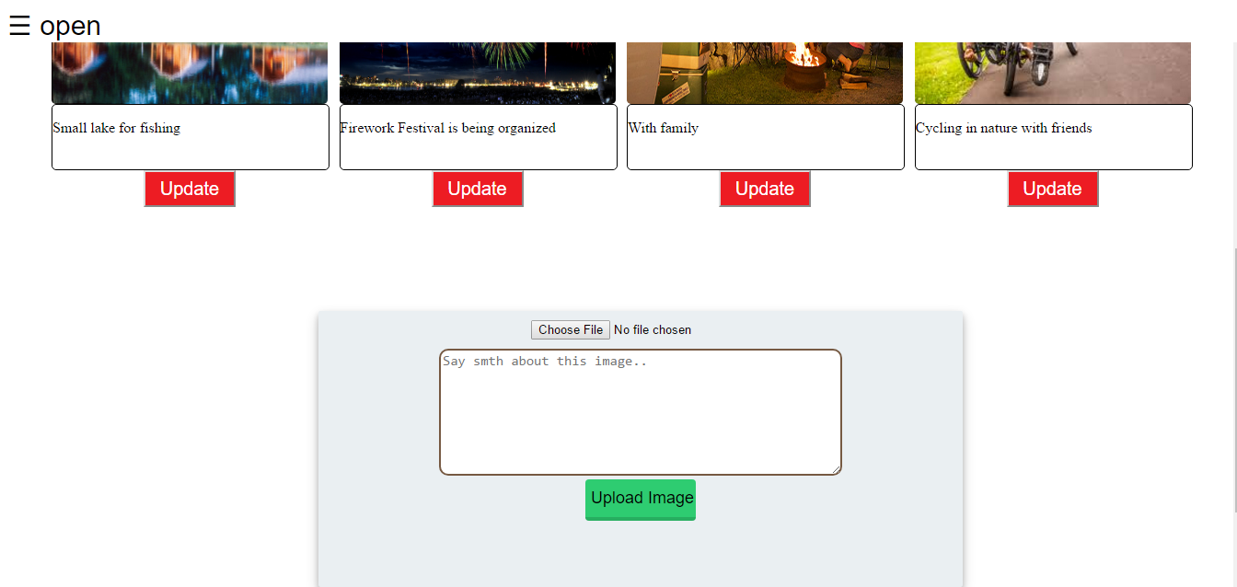

In this part **Admin press two times Update button** and Choose image from Desktop and write some news and upload News. Then new news is uploaded into database with image this change also reflect in News part which all of users can be informed.

**4)News Part:** In this part all News that has recently happened in campground is placed regularly by Admin.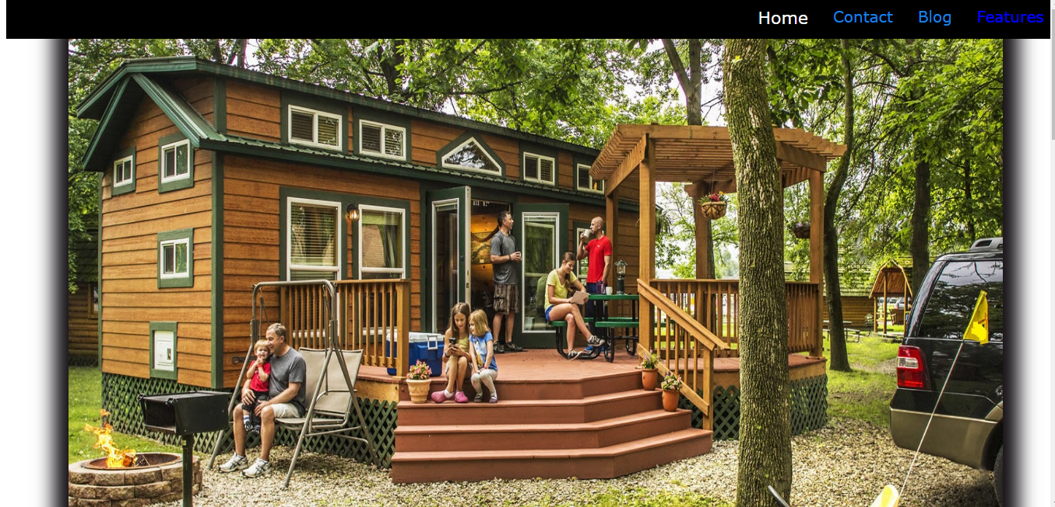



**5)Amenities:**  In this page Users can see all advantages inside Campground.

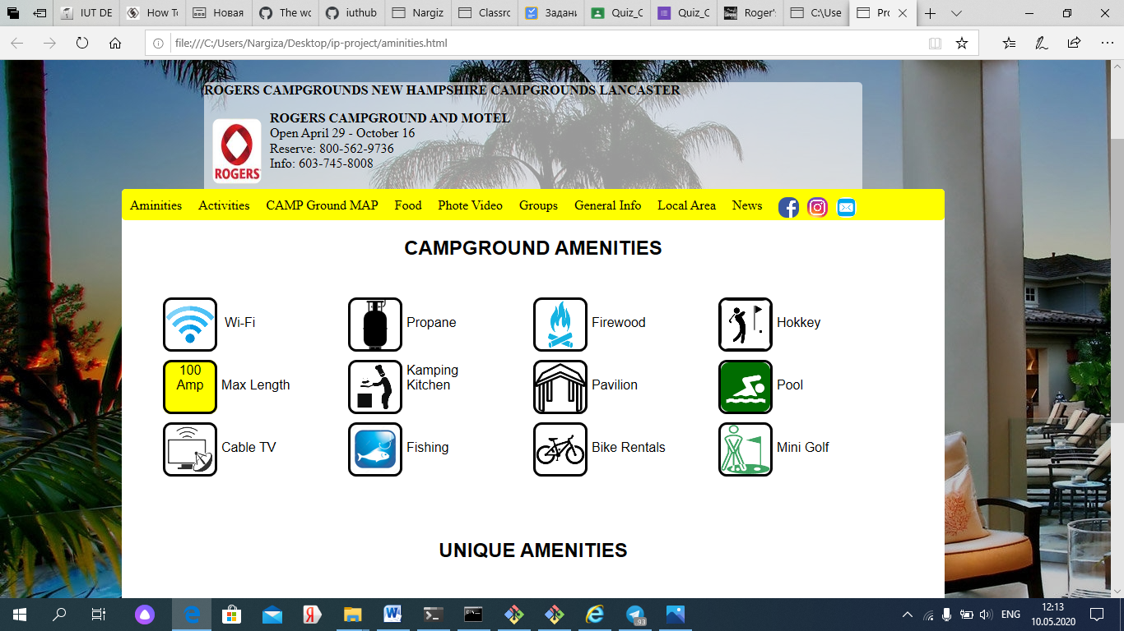

**6) Activities:** Customers are provided with several activities like this:

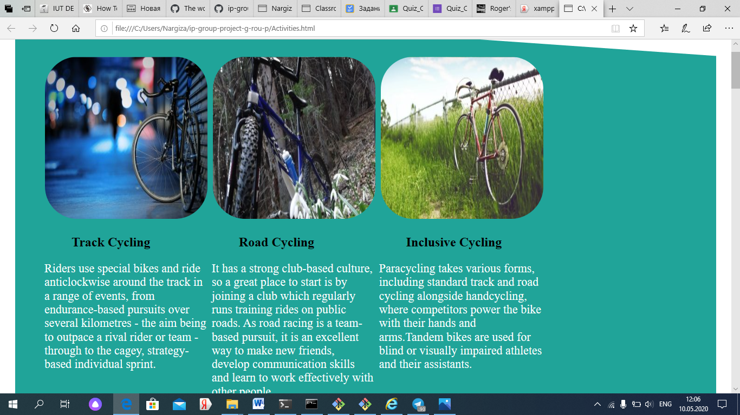

**Summary:**

**Working and committing parts of each student:**

1. Maksudov Abdumalik u1810255 – bootstrap.css parts, bootsrap.js, jquery,fonts and libs; Registration part
2. Sevinch Durjanova u1710305- worked with all of images and news part changes;
3. Yadgarova Aylisa u1710298– worked with activities html part ,css of navigation and carousel part and Main page php;
4. Ismoilova Nargiza u1710302- worked with front end ( amenity.css, aminities.css, aminities.html) and wrote report.
5. Bakhbaev Timur u1810177 - Worked with administration php.